Indonesian Foreign Minister: Indo-Pacific is not a Battle Ground

Jakarta, 14 July 2023 - "The Indo-Pacific is not a battle ground. This region must remain stable," said Indonesian Foreign Minister Retno Marsudi during the opening of the East Asia Summit (EAS) Foreign Ministers' Meeting in Jakarta on Friday (14/7).

The EAS consists of 18 member countries, including ASEAN members and their partners such as the United States, China, Russia, Japan, India, Australia, Korea, and New Zealand. The EAS serves as an inclusive platform to discuss the dynamics in the region and the world.

Foreign Minister Retno stated that people have high expectations for the EAS as the only forum that involves all key players in the Indo-Pacific region. Currently, the Indo-Pacific is at a crucial moment.

This region will be the largest contributor to global economic growth in the next 30 years. Significant developments in technology, medicine, and renewable energy are happening every day.

"However, we are still very far from ensuring a conducive environment to unlock the full potential of our region. Mistrust and uncertainties still exist. Some say the Indo-Pacific is experiencing symptoms of “a Cold War in Hot Places,” said the Foreign Minister.

In addition to being a net contributor to economic growth, the Indo-Pacific must also be a net contributor to peace and spread the paradigm of collaboration to other regions. The East Asia Summit (EAS) must contribute to realizing the collective aspirations of a peaceful, stable, and inclusive region.

"Imagine the EAS as a train, and our commitment to the Treaty of Amity and Cooperation (TAC) and the Bali Principles as the railways. We must make our paths cross and not block each other’s ways,” said the Foreign Minister.

All parties must work together to bridge differences, foster trust, and build an inclusive regional architecture. The existing differences should not be divisive but rather enrich collective efforts and become sources of strength.

The Foreign Minister cited the philosophy of 'Bhinneka Tunggal Ika,' which means unity in diversity, as a principle that emphasizes how harmony can be achieved through embracing differences to realize common goals. This spirit needs to be embraced by all EAS participants in their discussions and by listening to each other without prejudice.

"We are in this train of EAS. Everyone is welcome aboard," said the Foreign Minister.

Meanwhile, in Indonesia's national statement, the Foreign Minister emphasized two points. First, appreciation for the support and respect for ASEAN's centrality. A united ASEAN (ASEAN that matters) will bring benefits not only to the region but also to the world.

Second, a call to EAS member states to ensure the success of the upcoming East Asia Summit in September. The Foreign Minister urged all parties to "build bridges" and bring together existing differences.

During the meeting, the ASEAN Secretary-General highlighted that cooperation within the EAS framework continues to strengthen, particularly in areas such as green energy, environment, education, health, trade, food security, maritime security, and marine conservation.

The meeting discussed the dynamics in the region and globally, including efforts to promote peace in Ukraine, respect for international law in the South China Sea, stability on the Korean Peninsula, and the resolution of the Myanmar issue.

The meeting emphasized the crucial role of the EAS as a platform for cooperation and dialogue in promoting stability, peace, and prosperity in the region. Broad support was given to ASEAN's centrality, the implementation of the ASEAN Outlook on the Indo-Pacific, and the implementation of the Five-Point Consensus in addressing the Myanmar issue.

The meeting agreed upon the East Asia Summit Plan of Action 2024-2028, which identifies practical areas of cooperation and supports the mainstreaming and implementation of the ASEAN Outlook on the Indo-Pacific within the EAS framework.

***

For further information, please contact the following:

Director for Information and Media of the Ministry of Foreign Affairs - Hartyo Harkomoyo (+62811831899)

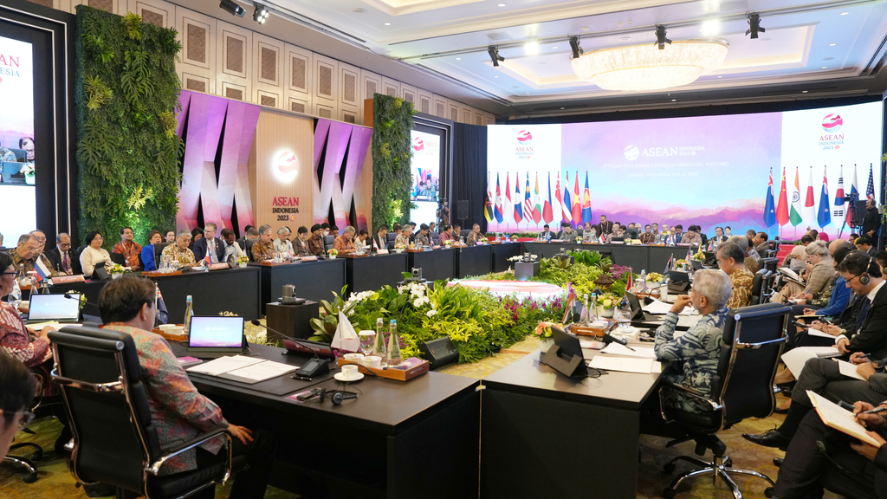
Indonesian Foreign Minister Retno Marsudi emphasized the Indo-Pacific is not a battle ground and must remain stable during the opening of the East Asia Summit (EAS) which serves as an inclusive platform to discuss the dynamics in the region and the world (14/7) (Photo: Ministry of Foreign Affairs of Indonesia).

